Name: Abhishek kumar(87)

Rohit Sonawane(80)

**A)tJoin and tfilterRow**

1. **Select metadata and then define the settings**

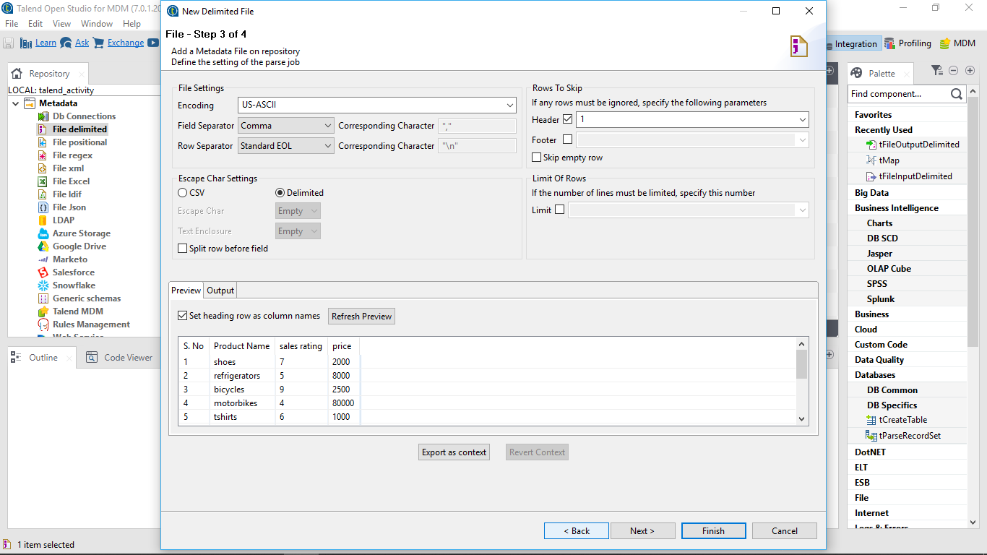

1. **Select the csv file from the system:**

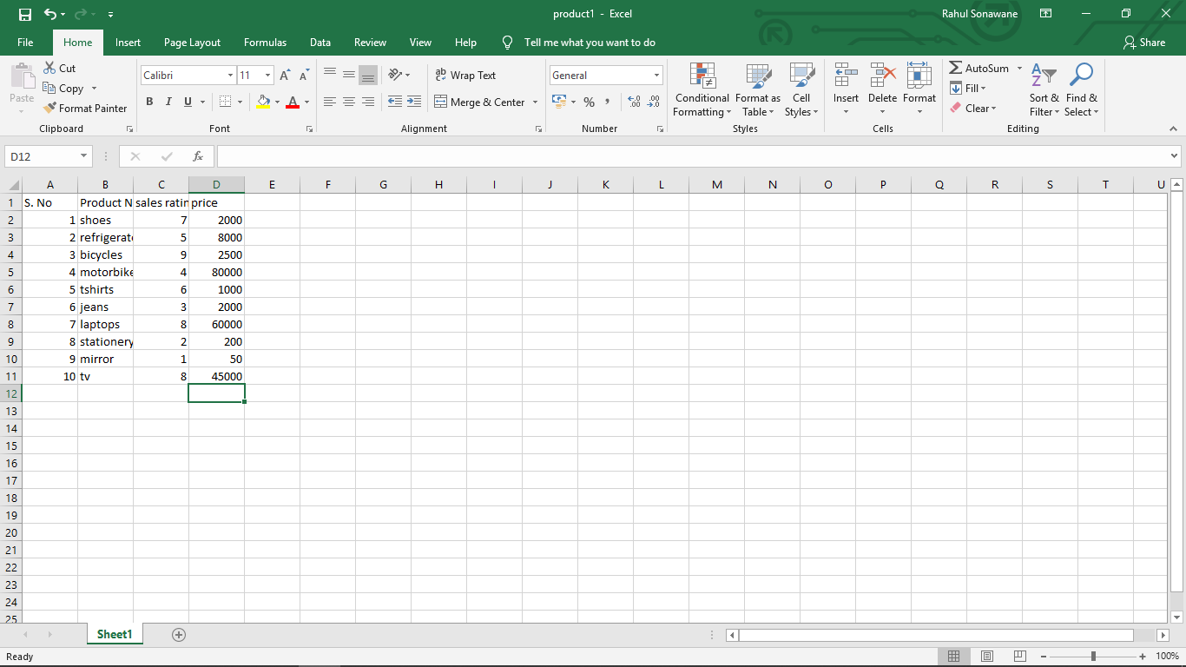

**3)insert the component tfileinputdeliminted followed by tfilterrow_1 and later the output file**

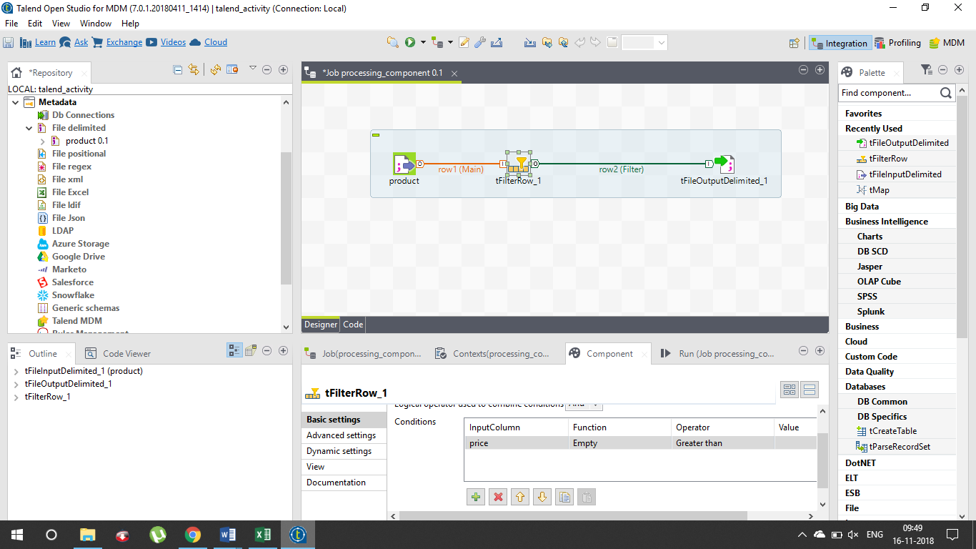

**4)after setting the conditions for the filtering of row we should run the program**

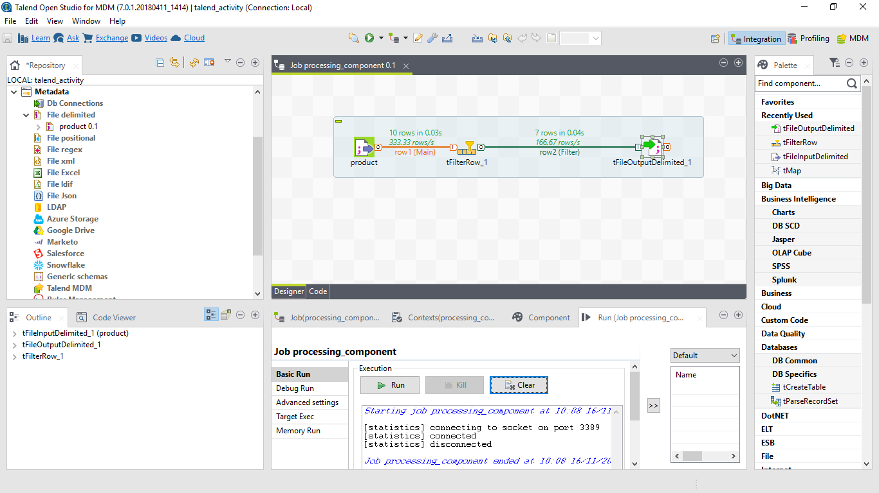

**5)this is the output file for the tfilterrow_1**

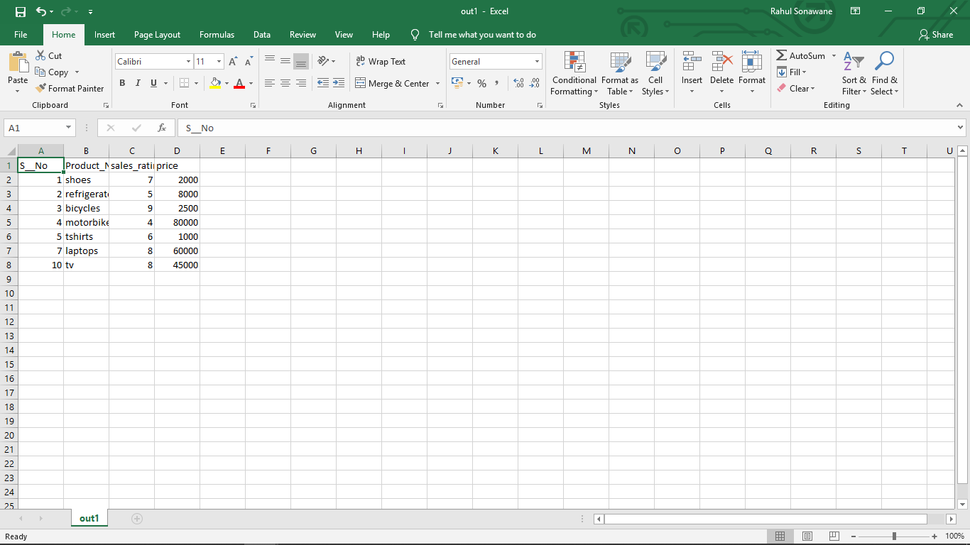

**B)tsortrow:**

**1)create the project as mentioned above, follow the same process till creating the job:**

**2)for designing the job we need to add some components that are tfileinputdelimited and tsortrow connected through main row within and output components i.e tfileputputdelimited**

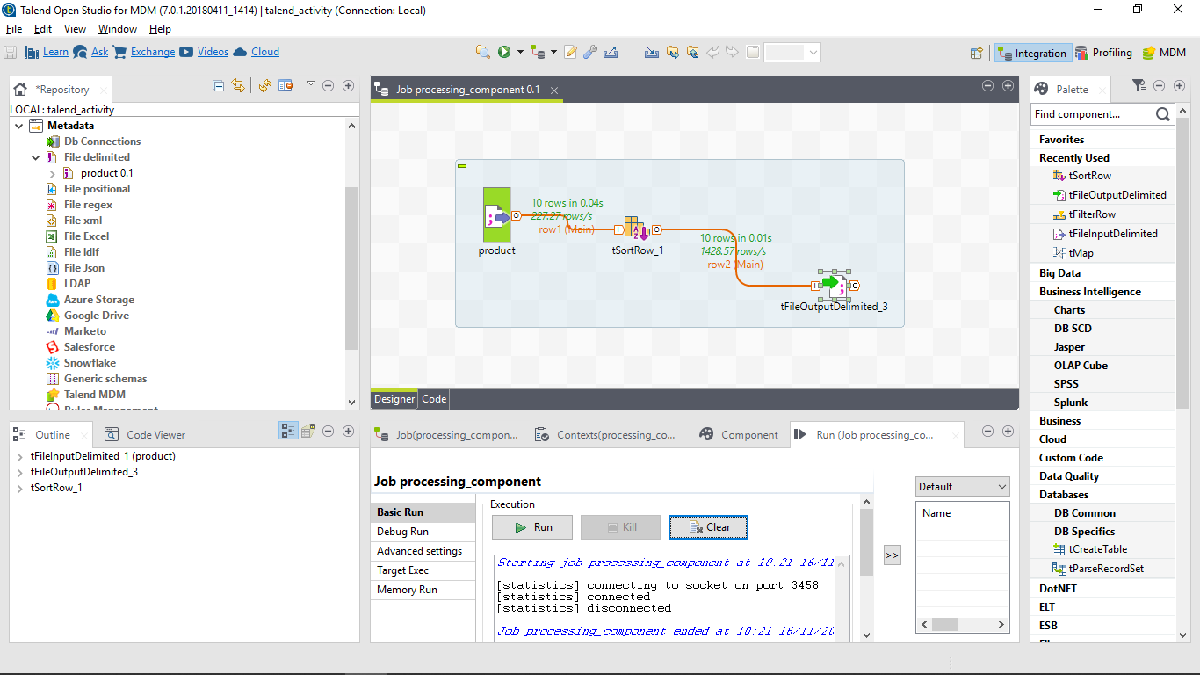

**3)after setting the parameter for sorting the list we can save the program and run it, we can have the following output**

